# SQL Server 2016 - OPENJSON read nested JSON and Insert INTO Tables

***Insert multiple level JSON data into SQL Server 2016*** –

Now Native [**JSON support in SQL Server 2016**](https://www.code-sample.com/2015/07/whats-new-in-sql-server-2016.html) and it provides you some functions to read and parse your JSON object to table format.

1.      The [**OPENJSON**](https://www.code-sample.com/2015/10/sql-interview-questions-answers.html) () table value function transforms JSON object to one or many rows. It will not execute any command. It just returns a table row if JSON text is properly formatted. OPENJSON function will also work with JSON arrays and this function can also open nested/hierarchical JSON objects. OPENJSON will just return set of rows instead of single row.

2.      The [**JSON_Value**](https://www.code-sample.com/2015/04/sql-server-tutorial.html) () is a scalar function and used to returns a value from JSON on the specified path.

There are some specific examples for OPENJSON read nested JSON –

*Example 1* – OPENJSON AND JSON INPUT

DECLARE @json NVARCHAR(MAX)

SET @json=N'{

"Name":"Anil",

"Surname":"Singh",

"Age":32,

"Skills":["SQL","C#","MVC","Angular 2, 4 and 5"]

}'

SELECT * FROM OPENJSON(@json);

*Result* –

[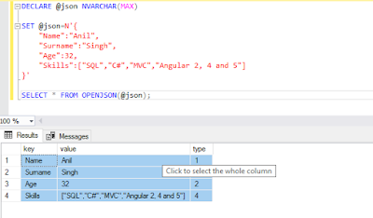](https://2.bp.blogspot.com/-HViO6RO_gEQ/WugWR3MQx4I/AAAAAAAASaY/FB-6ZSRmQMIVeeSUTy2iA_WSWaMjBSNPACLcBGAs/s1600/SQL-Server-OPENJSON-read-nested-JSON_1.png)

*Example* 2 – OPENJSON AND JSON INPUT

DECLARE @json NVARCHAR(MAX)

set @json =N'[

{

"CREATE_DT": 3443434343,

"INCLUDEIND_IND": true,

"CREATE_BY": "admin",

"DOMAIN_ID": "Cable Length",

"UPDATE_BY": null,

"VISIBLE": true,

"SOURCE": "OSB",

"MIN_VALUE": 2,

"UPDATE_DT": null,

"VERSION": 1,

"MAX_VALUE": 10

},

{

"CREATE_DT": 34334343433,

"INCLUDEIND_IND": true,

"CREATE_BY": "admin",

"DOMAIN_ID": "Number",

"UPDATE_BY": null,

"VISIBLE": true,

"SOURCE": "COB",

"MIN_VALUE": 1,

"UPDATE_DT": null,

"VERSION": 1,

"MAX_VALUE": 10

},

{

"CREATE_DT": 3434343,

"INCLUDEIND_IND": true,

"CREATE_BY": "admin",

"DOMAIN_ID": "Number_concurrent_access",

"UPDATE_BY": null,

"VISIBLE": true,

"SOURCE": "OCB",

"MIN_VALUE": 1,

"UPDATE_DT": null,

"VERSION": 1,

"MAX_VALUE": 5

}]'

CREATE TABLE TBL_ConvertJSONToTableObject(

CREATE_DT VARCHAR(30),

INCLUDEIND_IND VARCHAR(30),

CREATE_BY VARCHAR(30),

DOMAIN_ID VARCHAR(30) ,

UPDATE_BY VARCHAR(30) ,

VISIBLE VARCHAR(30) ,

SOURCE VARCHAR(30) ,

MIN_VALUE VARCHAR(30) ,

UPDATE_DT VARCHAR(30) ,

VERSION VARCHAR(30) ,

MAX_VALUE VARCHAR(30) ,

)

INSERT INTO TBL_ConvertJSONToTableObject (

CREATE_DT,

INCLUDEIND_IND,

CREATE_BY,

DOMAIN_ID,

UPDATE_BY,

VISIBLE ,

SOURCE ,

MIN_VALUE,

UPDATE_DT,

VERSION ,

MAX_VALUE

)

SELECT * FROM OPENJSON (@json)

WITH(

CREATE_DT VARCHAR(30) '$.CREATE_DT',

INCLUDEIND_IND VARCHAR(30) '$.INCLUDEIND_IND',

CREATE_BY VARCHAR(30) '$.CREATE_BY',

DOMAIN_ID VARCHAR(30) '$.DOMAIN_ID',

UPDATE_BY VARCHAR(30) '$.UPDATE_BY',

VISIBLE VARCHAR(30) '$.VISIBLE',

SOURCE VARCHAR(30) '$.SOURCE',

MIN_VALUE VARCHAR(30) '$.MIN_VALUE',

UPDATE_DT VARCHAR(30) '$.UPDATE_DT',

VERSION VARCHAR(30) '$.VERSION',

MAX_VALUE VARCHAR(30) '$.MAX_VALUE'

)

SELECT * FROM TBL_ConvertJSONToTableObject

*Result* –

[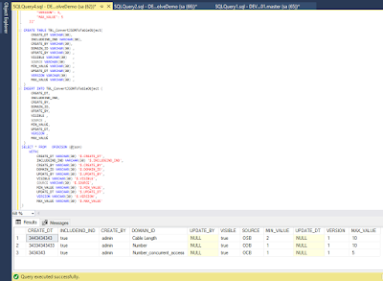](https://4.bp.blogspot.com/-Cvdy-ueXNAw/WugWYTqFtaI/AAAAAAAASac/JACKPsCgY54a-YdiZINndm_Pa8PgexeYgCLcBGAs/s1600/OPENJSON-read-nested-JSON_2.png)

*Example 3* –  USING JSON_VALUE() WITH OPENJSON() FUNCTION

DECLARE @json NVARCHAR(1000)

SELECT @json = N'{

"Orders": [

{

"OrderID": 10100,

"CustomerID": 202000,

"OrderDetail": [{

"ProductID": 302000,

"UnitPrice": 4350

},

{

"ProductID": 203000,

"UnitPrice": 4450

},

{

"ProductID": 43000,

"UnitPrice": 5560

}]

}]

}'

SELECT  JSON_Value (c.value, '$.OrderID') as OrderID,

JSON_Value (c.value, '$.CustomerID') as CustomerID,

JSON_Value (p.value, '$.ProductID') as ProductID,

JSON_Value (p.value, '$.UnitPrice') as UnitPrice

FROM OPENJSON (@json, '$.Orders') as c

                                CROSS APPLY OPENJSON (c.value, '$.OrderDetail') as p

*Result* –

[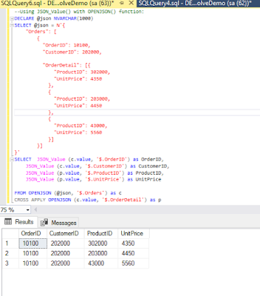](https://2.bp.blogspot.com/-stsdVNMmN5M/WugWeZHeSXI/AAAAAAAASag/k8aWmnqkFF0VW9D-TwILUmt4R_UFFkMMgCLcBGAs/s1600/OPENJSON-read-nested-JSON_3.png)